Class Assignment 6

Create a page like that

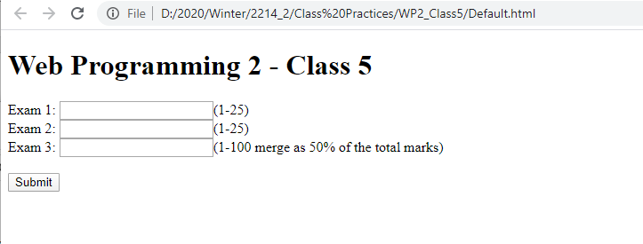

When you click on submit button

Calculate the total score.

Display the score.

Display the grade based on the score

>80 A

60-80 B

<60 F

**Use JQuery Framework to solve the problem.**

**How to submit:**

Compress the folder.

Take Screen Shots of your HTML, CSS, and JavaScript codes attach those to this file.

Upload the compressed folder and word document in moodle.

**Answer here:**

